

**Capstone Project Report**

**Report 3 – Software Requirement Specification**

– Hanoi, Jan 25th, 2021 –

**Table of Contents**

I. Software Requirement Specification 3

1. Overall Description 3

1.1 Product Overview 3

1.2 Business Rules 4

2. User Requirements 5

2.1 Overview 5

2.2 <<Feature Name 1 – i.e Order Meals>> 6

2.3 <<Feature name 2 – i.e: Meal Subscriptions>> 10

2.4 <<Next Feature Name..>> 10

3. Functional Requirements 11

3.1 System Functional Overview 11

3.2 <<Feature Name 1>> 13

3.3 <<Feature Name 2>> 13

4. Non-Functional Requirements 14

4.1 External Interfaces 14

4.2 Quality Attributes 15

5. Other Requirements 17

5.1 Appendix1 - Messages List 17

5.2 Appendix2 - … 17

5.3 … 17

# I. Software Requirement Specification

## 1. Overall Description

### 1.1 Product Overview

*[This section presents a high-level overview of the product and the environment in which it will be used, the anticipated users, and known constraints, assumptions, and dependencies]*

*[This section Describe the product's context and origin of the product you are developing. Is it the next member of a growing product line, the next version of a mature system, a replacement for an existing application, or an entirely new product? If this SRS defines a component of a larger system, state how this software relates to the overall system and identify major interfaces between the two. Consider including visual models such as a context diagram or ecosystem map to show the product's relationship to other systems or anything else in the universe.*

*The context diagram presents the boundary and connections between the system you’re developing and everything else in the universe. This identifies external entities (or terminators – software, hardware, human components, and other systems) outside the system that interface to it in some way, as well as data, control, and material flows between the terminators and the system.*

*An ecosystem map shows all of the systems related to the system of interest that interact with one another and the nature of those interactions. It represents scope by showing all the systems that interconnect (directly or indirectly) and that therefore might need to be modified to accommodate your new system]*

<<Sample: The Cafeteria Ordering System is a new software system that replaces the current manual and telephone processes for ordering and picking up meals in the Process Impact cafeteria. The context diagram below illustrates the external entities and system interfaces for release 1.0. The system is expected to evolve over several releases, ultimately connecting to the Internet ordering services for several local restaurants and to credit and debit card authorization services.

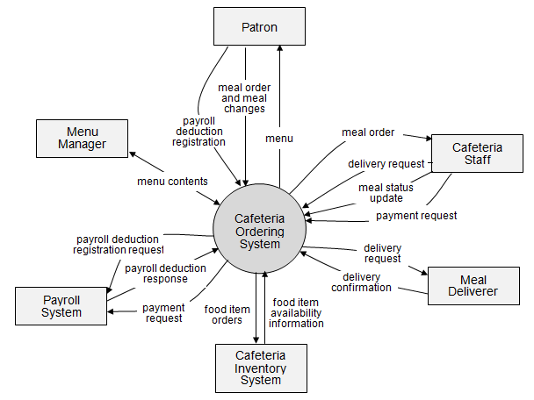

>>

### 1.2 Business Rules

*[Provide common business rules that you must follow. The information can be provided in the table format as the sample below]*

|  |  |
| --- | --- |
| ID | Rule Definition |
| BR-01 | Delivery time windows are 15 minutes, beginning on each quarter hour. |
| BR-02 | Deliveries must be completed between 10:00 A.M. and 2:00 P.M. local time, inclusive. |
| BR-03 | All meals in a single order must be delivered to the same location. |
| BR-04 | All meals in a single order must be paid for by using the same payment method. |
| BR-11 | If an order is to be delivered, the patron must pay by payroll deduction. |
| BR-12 | Order price is calculated as the sum of each food item price times the quantity of that food item ordered, plus applicable sales tax, plus a delivery charge if a meal is delivered outside the free delivery zone. |
| BR-24 | Only cafeteria employees who are designated as Menu Managers by the Cafeteria Manager can create, modify, or delete cafeteria menus. |
| BR-33 | Network transmissions that involve financial information or personally identifiable information require 256-bit encryption. |
| BR-86 | Only regular employees can register for payroll deduction for any company purchase. |
| BR-88 | An employee can register for payroll deduction payment of cafeteria meals if no more than 40 percent of his gross pay is currently being deducted for other reasons. |

## 2. User Requirements

***(This is optional part)***

### 2.1 Overview

#### a. Use Case Diagram

*[Provide your use case diagram(s) which is something like the sample below]*

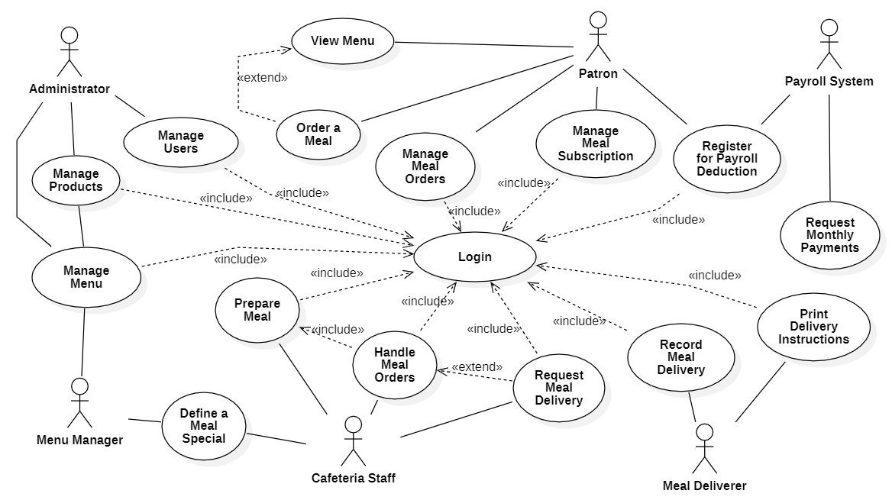

#### b. System Actors

*[An actor is a person (or sometimes another software system or a hardware device) that interacts with the system to perform a use case. Following are some questions you might ask to help user representatives identify actors*

* *Who (or what) is notified when something occurs within the system?*
* *Who (or what) provides information or services to the system?*
* *Who (or what) helps the system respond to and complete a task?*

*This part give the description of system actors, you can follow the table form as below]*

|  |  |  |
| --- | --- | --- |
| **#** | **Actor** | **Description** |
| 1 | Administrator |  |
| 2 | Menu Manager |  |
| 3 | … |  |

#### c. Use Cases List

*[A use case describes a sequence of interactions between a system and an external actor that results in the actor being able to achieve some outcome of value. The names of use cases are always written in the form of a verb followed by an object. Select strong, descriptive names to make it evident from the name that the use case will deliver something valuable for some user; This part describe the use cases, you can follow the table form as below, in which: the primary actors initiate the use case and derive the main value from it, the secondary actors are the person or system which will participate in completing execution of the use case (participates somehow in the successful execution of the use case)]*

|  |  |  |  |
| --- | --- | --- | --- |
| **ID** | **Use Case** | **Actors** | **Use Case Description** |
| 01 | View Menu | Patron |  |
| 02 | Order a Meal | Patron |  |
| 03 | Manage Meal Orders | Patron |  |
| 04 | Register for Payroll Deduction | Patron | Payroll System |
| 05 | Request Monthly Payments | [Auto] | Payroll System |
| 06 | Manage Meal Subscription | Patron |  |
| 07 | Manage Menu  *(View, Create, Modify, Delete, Archive)* | Administrator,  Menu Manager |  |
| 08 | Define a Meal Special | Menu Manager,  Cafeteria Staff |  |
| 09 | Handle Meal Orders | Cafeteria Staff |  |
| 10 | Prepare Meal | Cafeteria Staff |  |
| 11 | Request Meal Delivery | Cafeteria Staff |  |
| 12 | Record Meal Delivery | Deliverer |  |
| 13 | Print Delivery Instructions | Deliverer |  |
| 14 | Manage Users | Administrator |  |
| 15 | Login | [Guest] |  |

### 2.2 <<Feature Name 1 – i.e Order Meals>>

#### a. <<Use Case Name 1.1>>

*[Provide the specification for the related use case following the table format as below.*

|  |  |  |  |
| --- | --- | --- | --- |
| UC ID and Name: |  | | |
| Created By: |  | Date Created: |  |
| Primary Actor: |  | Secondary Actors: |  |
| Trigger: |  | | |
| Description: |  | | |
| Preconditions: |  | | |
| Post-conditions: |  | | |
| Normal Flow: |  | | |
| Alternative Flows: |  | | |
| Exceptions: |  | | |
| Priority: | High (Medium, Low) | | |
| Frequency of Use: |  | | |
| Business Rules: |  | | |
| Other Information: |  | | |
| Assumptions: |  | | |

*In which:*

***Use Case ID and Name***

*Give each use case a unique integer sequence number identifier. State a concise name for the use case that indicates the value the use case would provide to some user. Begin with an action verb, followed by an object.*

***Author and Date Created***

*Enter the name of the person who initially wrote this use case and the date it was written.*

***Primary and Secondary Actors***

*An actor is a person or other entity external to the software system being specified who interacts with the system and performs use cases to accomplish tasks. Different actors often correspond to different user classes, or roles, identified from the customer community that will use the product. Name the primary actor that will be initiating this use case and any other secondary actors who will participate in completing execution of the use case.*

***Trigger***

*Identify the business event, system event, or user action that initiates the use case. This trigger alerts the system that it should begin testing the preconditions for the use case so it can judge whether to proceed with execution.*

***Description***

*Provide a brief description of the reason for and outcome of this use case, or a high-level description of the sequence of actions and the outcome of executing the use case.*

***Preconditions***

*List any activities that must take place, or any conditions that must be true, before the use case can be started. The system must be able to test each precondition. Number each precondition. Example: PRE-1: User’s identity has been authenticated.*

***Post-conditions***

*Describe the state of the system at the successful conclusion of the use case execution. Label each post-condition in the form POST-X, where X is a sequence number. Example: POST-1: Price of item in the database has been updated with the new value.*

***Normal Flow***

*Provide a description of the user actions and corresponding system responses that will take place during execution of the use case under normal, expected conditions. This dialog sequence will ultimately lead to accomplishing the goal stated in the use case name and description. Show a numbered list of actions performed by the actor, alternating with responses provided by the system. The normal flow is numbered “X.0”, where “X” is the Use Case ID.*

***Alternative Flows***

*Document other successful usage scenarios that can take place within this use case. State the alternative flow, and describe any differences in the sequence of steps that take place. Number each alternative flow in the form “X.Y”, where “X” is the Use Case ID and Y is a sequence number for the alternative flow. For example, “5.3” would indicate the third alternative flow for use case number 5. Indicate where each alternative flow would branch off from the normal flow, and if pertinent, where it would re-join the normal flow.*

***Exceptions***

*Describe any anticipated error conditions that could occur during execution of the use case and how the system is to respond to those conditions. Number each alternative flow in the form “X.Y.EZ”, where “X” is the Use Case ID, Y indicates the normal (0) or alternative (>0) flow during which this exception could take place, “E” indicates an exception, and “Z” is a sequence number for the exceptions. For example “5.0.E2” would indicate the second exception for the normal flow for use case number 5. Indicate where in the normal (or an alternative) flow each exception could occur.*

***Priority***

*Indicate the relative priority of implementing the functionality required to allow this use case to be executed. Use the same priority scheme as that used for the functional requirements.*

***Frequency of Use***

*Estimate the number of times this use case will be performed per some appropriate unit of time. This gives an early indicator of throughput, concurrent usage loads, and transaction capacity.*

***Business Rules***

*List any business rules that influence this use case. Don’t include the business rule text here, just its identifier so the reader can find it in another repository when needed.*

***Other Information***

*Identify any additional requirements, such as quality attributes, for the use case that may need to be addressed during design or implementation. Also list any associated functional requirements that aren’t a direct part of the use case flows but which a developer needs to know about. Describe what should happen if the use case execution fails for some unanticipated or systemic reason (e.g., loss of network connectivity, timeout). If the use case results in a durable state change in a database or the outside world, state whether the change is rolled back, completed correctly, partially completed with a known state, or left in an undetermined state as a result of the exception.*

***Assumptions***

*List any assumptions that were made regarding this use case or how it might execute.*

*You can see the samples in the next sections]*

#### b. <<Use Case Name 1.2 – i.e Order a Meal

|  |  |  |  |
| --- | --- | --- | --- |
| ID and Name: | **UC-01 Order a Meal** | | |
| Created By: | Prithvi Raj | Date Created: | 10/4/13 |
| Primary Actor: | Patron | Secondary Actors: | Cafeteria Inventory System |
| Description: | A Patron accesses the Cafeteria Ordering System from the corporate intranet or from home, views the menu for a specific date if desired, selects food items, and places an order for a meal to be delivered to a specified location within a specified 15-minute time window. | | |
| Trigger: | A Patron indicates that he wants to order a meal | | |
| Preconditions: | PRE-1. Patron is logged into COS.  PRE-2. Patron is registered for meal payments by payroll deduction. | | |
| Post-conditions: | POST-1. Meal order is stored in COS with a status of “Accepted”.  POST-2. Inventory of available food items is updated to reflect items in this order.  POST-3. Remaining delivery capacity for the requested time window is updated. | | |
| Normal Flow: | **1.0 Order a Single Meal**   1. Patron asks to view menu for a specific date. (see 1.0.E1, 1.0.E2) 2. COS displays menu of available food items and the daily special. 3. Patron selects one or more food items from menu. (see 1.1) 4. Patron indicates that meal order is complete. (see 1.2) 5. COS displays ordered menu items, individual prices, and total price, including taxes and delivery charge. 6. Patron either confirms meal order (continue normal flow) or requests to modify meal order (return to step 2). 7. COS displays available delivery times for the delivery date. 8. Patron selects a delivery time and specifies the delivery location. 9. Patron specifies payment method. 10. COS confirms acceptance of the order. 11. COS sends Patron an email message confirming order details, price, and delivery instructions. 12. COS stores order, sends food item information to Cafeteria Inventory System, and updates available delivery times. | | |
| Alternative Flows: | **1.1 Order multiple identical meals**  Patron requests a specified number of identical meals. (see 1.1.E1)  Return to step 4 of normal flow.  **1.2 Order multiple meals**  Patron asks to order another meal.  Return to step 1 of normal flow. | | |
| Exceptions: | **1.0.E1 Requested date is today and current time is after today’s order cutoff time**  1. COS informs Patron that it’s too late to place an order for today.  2a. If Patron cancels the meal ordering process, then COS terminates use case.  2b. Else if Patron requests another date, then COS restarts use case.  **1.0.E2 No delivery times left**  1. COS informs Patron that no delivery times are available for the meal date.  2a. If Patron cancels the meal ordering process, then COS terminates use case.  2b. Else if Patron requests to pick the order up at the cafeteria, then continue with normal flow, but skip steps 7 and 8.  **1.1.E1 Insufficient inventory to fulfill multiple meal order**  1. COS informs Patron of the maximum number of identical meals he can order, based on current available inventory.  2a. If Patron modifies number of meals ordered, then Return to step 4 of normal flow.  2b. Else if Patron cancels the meal ordering process, then COS terminates use case. | | |
| Priority: | High | | |
| Frequency of Use: | Approximately 300 users, average of one usage per day. Peak usage load for this use case is between 9:00 A.M. and 10:00 A.M. local time. | | |
| Business Rules: | BR-1, BR-2, BR-3, BR-4, BR-11, BR-12, BR-33 | | |
| Other Information: | 1. Patron shall be able to cancel the meal ordering process at any time prior to confirming it. 2. Patron shall be able to view all meals he ordered within the previous six months and repeat one of those meals as the new order, provided that all food items are available on the menu for the requested delivery date. (Priority = M) 3. The default date is the current date if the Patron is using the system before today’s order cutoff time. Otherwise, the default date is the next day that the cafeteria is open. | | |
| Assumptions: | Assume that 15 percent of Patrons will order the daily special (source: previous 6 months of cafeteria data). | | |

#### c. <<Next Use Case Name 1.x>>

*…*

### 2.3 <<Feature name 2 – i.e: Meal Subscriptions>>

#### a. <<Use Case Name 2.1 – i.e Register for Payroll Deduction>>

|  |  |  |  |
| --- | --- | --- | --- |
| ID and Name: | **UC-05 Register for Payroll Deduction** | | |
| Created By: | Nancy Anderson | Date Created: | 9/15/13 |
| Primary Actor: | Patron | Secondary Actors: | Payroll System |
| Description: | Cafeteria patrons who use the COS and have meals delivered must be registered for payroll deduction. For noncash purchases made through the COS, the cafeteria will issue a payment request to the Payroll System, which will deduct the meal costs from the next scheduled employee payday direct deposit. | | |
| Trigger: | Patron requests to register for payroll deduction, or Patron says yes when COS asks if he wants to register | | |
| Preconditions: | PRE-1. Patron is logged into COS. | | |
| Postconditions: | POST-2. Patron is registered for payroll deduction. | | |
| Normal Flow: | **5.0 Register for Payroll Deduction**   1. COS asks Payroll System if Patron is eligible to register for payroll deduction. 2. Payroll System confirms that Patron is eligible to register for payroll deduction. 3. COS asks Patron to confirm his desire to register for payroll deduction. 4. If so, COS asks Payroll System to establish payroll deduction for Patron. 5. Payroll System confirms that payroll deduction is established. 6. COS informs Patron that payroll deduction is established. | | |
| Alternative Flows: | None | | |
| Exceptions: | 5.0.E1 Patron is not eligible for payroll deduction  5.0.E2 Patron is already enrolled for payroll deduction | | |
| Priority: | High | | |
| Frequency of Use: |  | | |
| Business Rules: | BR-86 and BR-88 govern an employee’s eligibility to enroll for payroll deduction. | | |
| Other Information: | Expect high frequency of executing this use case within first 2 weeks after system is released. | | |
| Assumptions: |  | | |

#### b. <<Next Use Case Name 2.x>>

*[Use Case Description in the same format as above]*

### 2.4 <<Next Feature Name..>>

…

## 3. Functional Requirements

### 3.1 System Functional Overview

#### a. Screen Flow

*[This part show the system screens and the relationship among screens. You can draw the Screens Flow for the system in the form of diagram as below]*

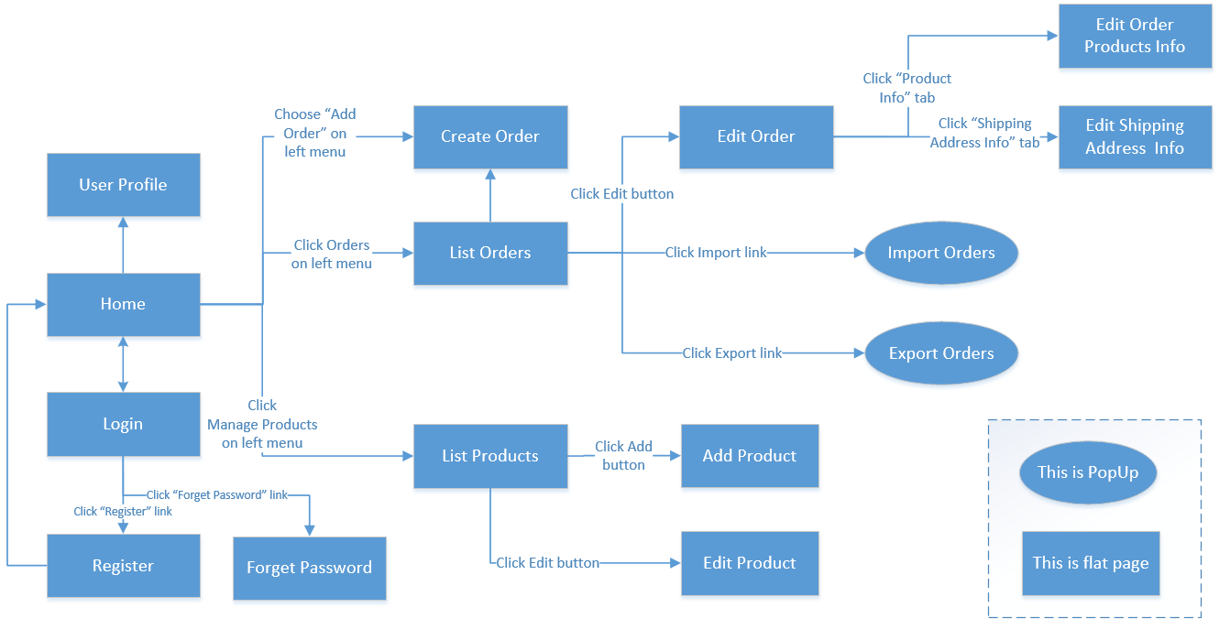

#### b. Screen Details

*[Provide the descriptions for the screens in the Screens Flow above]*

|  |  |  |  |
| --- | --- | --- | --- |
| **#** | **Feature** | **Screen** | **Description** |
| 1 | Order Meals | Create Order | <<Screen Brief description>> |
| 2 | Order Meals | Change Order |  |
| 3 | .. |  |  |

#### c. Screen Authorization

*[Provide the system roles authorization to the system features (down to screens, and event to the screen activities if applicable) in the table form as below – replace Role1, Role2,… with the specific system user role names]*

|  |  |  |  |  |  |
| --- | --- | --- | --- | --- | --- |
| **Screen** | **Role1** | **Role2** | **Role3** | **Role4** | **RoleX** |
| <<Screen Name1>> | X |  |  | X | X |
| <<Screen Activity>> |  |  |  | X | X |
| <<Screen Name2>> | X |  |  | X |  |
| Query All Data | X |  |  |  |  |
| Query Own Data |  |  |  | X |  |
| Query Managed Data |  |  |  | X |  |
| Add New Data |  |  |  | X | X |
| Update All Data |  |  |  |  | X |
| Update Own Data |  |  |  |  | X |
| Update Managed Data |  |  |  |  | X |
| Delete Data |  |  |  |  |  |
| … |  |  |  |  |  |

In which:

* Role1: <<role1 description>>
* Role2: <<role2 description>>
* …

#### d. Non-Screen Functions

*[Provide the descriptions for the non-screen system functions, i.e batch/cron job, service, API, etc.]*

|  |  |  |  |
| --- | --- | --- | --- |
| **#** | **Feature** | **System Function** | **Description** |
| 1 | <<Feature Name>> | <<Function Name1>> | <<Function Name1 Description>> |
| 2 | … |  |  |

#### e. Entity Relationship Diagram

*[Provide the entity relationship diagram and the entity descriptions in the table format as below]*



**Entities List**

|  |  |  |
| --- | --- | --- |
| **#** | **Entity** | **Description** |
| 1 | User |  |
| 2 | Meal |  |
| 3 | Meal Subscription |  |
| 4 | … |  |

### 3.2 <<Feature Name 1>>

#### a. <<Function Name 1>>

*[A function can be a screen or a non-screen function (listed in the part 5.1 above). In this part, you need to provide the details on the related function, focus on mentioning below information*

* *Function trigger: how this function is triggered (navigation path, a timing frequency, etc.*
* *Function description: actors/roles, purpose, interface, data processing, etc.*
* *Screen layout: mockup prototype of the screen, sample below is for Manage Products screen*

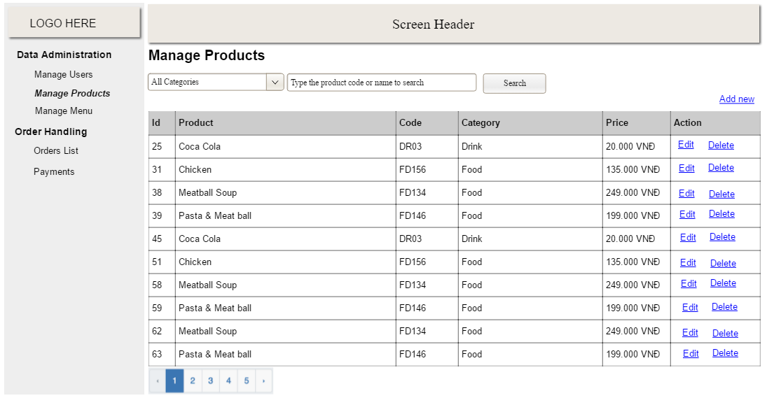

* *Function Details: provide explanation for the data, validation, functionalities (for both normal cases and abnormal cases), etc. of the function so that the reader can image how it work.*

*]*

#### b. <<Function Name 2>>

…

### 3.3 <<Feature Name 2>>

…

## 4. Non-Functional Requirements

### 4.1 External Interfaces

*[This section provides information to ensure that the system will communicate properly with users and with external hardware or software elements.]*

#### a. User Interfaces

*[Describe the logical characteristics of each interface between the software product and the users. This may include sample screen images, any GUI standards or product family style guides that are to be followed, screen layout constraints, standard buttons and functions (e.g., help) that will appear on every screen, keyboard shortcuts, error message display standards, and so on. Define the software components for which a user interface is needed. Details of the user interface design should be documented in a separate user interface specification.]*

UI-1: The Cafeteria Ordering System screen displays shall conform to the Process Impact Internet Application User Interface Standard, Version 2.0 [3].

UI-2: The system shall provide a help link from each displayed webpage to explain how to use that page.

UI-3: The webpages shall permit complete navigation and food item selection by using the keyboard alone, in addition to using mouse and keyboard combinations.

#### b. Software Interfaces

*[Describe the connections between this product and other software components (identified by name and version), including other applications, databases, operating systems, tools, libraries, websites, and integrated commercial components. State the purpose, formats, and contents of the messages, data, and control values exchanged between the software components. Specify the mappings of input and output data between the systems and any translations that need to be made for the data to get from one system to the other. Describe the services needed by or from external software components and the nature of the inte-component communications. Identify data that will be exchanged between or shared across software components. Specify non-functional requirements affecting the interface, such as service levels for responses times and frequencies, or security controls and restrictions.]*

SI-1: Cafeteria Inventory System

SI-1.1: The COS shall transmit the quantities of food items ordered to the Cafeteria Inventory System through a programmatic interface.

SI-1.2: The COS shall poll the Cafeteria Inventory System to determine whether a requested food item is available.

SI-1.3: When the Cafeteria Inventory System notifies the COS that a specific food item is no longer available, the COS shall remove that food item from the menu for the current date.

SI-2: Payroll System

The COS shall communicate with the Payroll System through a programmatic interface for the following operations:

SI-2.1: To allow a Patron to register and unregister for payroll deduction.

SI-2.2: To inquire whether a Patron is registered for payroll deduction.

SI-2.3: To inquire whether a Patron is eligible to register for payroll deduction.

SI-2.4: To submit a payment request for a purchased meal.

SI-2.5: To reverse all or part of a previous charge because a patron rejected a meal or wasn’t satisfied with it, or because the meal was not delivered per the confirmed delivery instructions.

#### c. Hardware Interfaces

*[Describe the characteristics of each interface between the software and hardware (if any) components of the system. This description might include the supported device types, the data and control interactions between the software and the hardware, and the communication protocols to be used. List the inputs and outputs, their formats, their valid values or ranges, and any timing issues developers need to be aware of. If this information is extensive, consider creating a separate interface specification document]*

No hardware interfaces have been identified.

#### d. Communications Interfaces

*[State the requirements for any communication functions the product will use, including e-mail, Web browser, network protocols, and electronic forms. Define any pertinent message formatting. Specify communication security or encryption issues, data transfer rates, handshaking, and synchronization mechanisms. State any constraints around these interfaces, such as whether e-mail attachments are acceptable or not.]*

CI-1: The COS shall send an email or text message (based on user account settings) to the Patron to confirm acceptance of an order, price, and delivery instructions.

CI-2: The COS shall send an email or text message (based on user account settings) to the Patron to report any problems with the meal order or delivery.

### 4.2 Quality Attributes

*[List all the required system characteristics (quality attributes) specification. Some of the possible attributes are provided with the guide/descriptions are mentioned here]*

#### a. Usability

*[This section includes all those requirements that affect usability. For example, specify the required training time for a normal users and a power user to become productive at particular operations specify measurable task times for typical tasks or base the new system’s usability requirements on other systems that the users know and like specify requirement to conform to common usability standards, such as IBM’s CUA standards Microsoft’s GUI standards]*

#### b. Reliability

*[Requirements for reliability of the system should be specified here. Some suggestions follow:*

*Availability—specify the percentage of time available ( xx.xx%), hours of use, maintenance access, degraded mode operations, and so on.*

*Mean Time Between Failures (MTBF) — this is usually specified in hours, but it could also be specified in terms of days, months or years.*

*Mean Time To Repair (MTTR)—how long is the system allowed to be out of operation after it has failed?*

*Accuracy—specifies precision (resolution) and accuracy (by some known standard) that is required in the system’s output.*

*Maximum Bugs or Defect Rate—usually expressed in terms of bugs per thousand lines of code (bugs/KLOC) or bugs per function-point( bugs/function-point).*

*Bugs or Defect Rate—categorized in terms of minor, significant, and critical bugs: the requirement(s) must define what is meant by a “critical” bug; for example, complete loss of data or a complete inability to use certain parts of the system’s functionality.]*

#### c. Performance

*[The system’s performance characteristics are outlined in this section. Include specific response times. Where applicable, reference related Use Cases by name.*

*Response time for a transaction (average, maximum)*

*Throughput, for example, transactions per second*

*Capacity, for example, the number of customers or transactions the system can accommodate*

*Degradation modes (what is the acceptable mode of operation when the system has been degraded in some manner)*

*Resource utilization, such as memory, disk, communications, and so forth.]*

#### d. Dependability

*[Software dependability includes a range of characteristics including reliability, security and safety. Dependable software should not cause physical or economic damage in the event of system failure. Malicious users should not be able to access or damage the system]*

##### d1. Security

*[Specify any requirements regarding security or privacy issues that restrict access to or use of the product. These could refer to physical, data, or software security. Security requirements often originate in business rules, so identify any security or privacy policies or regulations to which the product must conform. If these are documented in a business rules repository, just refer to them.]*

##### d2. Safety

*[Specify requirements that are concerned with possible loss, damage, or harm that could result from use of the product. Define any safeguards or actions that must be taken, as well as potentially dangerous actions that must be prevented. Identify any safety certifications, policies, or regulations to which the product must conform.]*

#### e. Supportability

*[This section indicates any requirements that will enhance the supportability or maintainability of the system being built, including coding standards, naming conventions, class libraries, maintenance access, and maintenance utilities.]*

#### f. Design Constraints

*[This section indicates any design constraints on the system being built. Design constraints represent design decisions that have been mandated and must be adhered to. Examples include software languages, software process requirements, prescribed use of developmental tools, architectural and design constraints, purchased components, class libraries, and so on.]*

#### g. Support Documents

*[Describes the requirements, if any, for o-line user documentation, help systems, help about notices, and so forth.]*

#### h. Purchased Components

*[This section describes any purchased components to be used with the system, any applicable licensing or usage restrictions, and any associated compatibility and interoperability or interface standards.]*

## 5. Other Requirements

*[Examples are: legal, regulatory or financial compliance, and standards requirements; requirements for product installation, configuration, startup, and shutdown; and logging, monitoring and audit trail requirements. Instead of just combining these all under "Other," add any new sections to the template that are pertinent to your project. Omit this section if all your requirements are accommodated in other sections. ]*

### 5.1 Appendix1 - Messages List

|  |  |  |  |  |
| --- | --- | --- | --- | --- |
| **#** | **Message code** | **Message Type** | **Context** | **Content** |
| 1 | MSG01 | In line | There is not any search result | *No search result.* |
| 2 | MSG02 | In red, under the text box | Input-required fields are empty | *The * field is required.* |
| 3 | MSG03 | Toast message | Updating asset(s) information successfully | *Update asset(s) successfully.* |
| 4 | MSG04 | Toast message | Adding new asset successfully | *Add asset successfully.* |
| 5 | MSG05 | Toast message | Confirming email of asset hand-over is sent successfully | *A confirmation email has been sent to {email_address}.* |
| 6 | MSG06 | Toast message | Resetting asset information successfully | *Return asset(s) successfully.* |
| 7 | MSG07 | Toast message | Deleting asset information successfully | *Delete asset(s) successfully.* |
| 8 | MSG08 | In red, under the text box | Input value length > max length | *Exceed max length of {max_length}.* |
| 9 | MSG09 | In line | Username or password is not correct when clicking sign-in | *Incorrrect user name or password. Please check again.* |

### 5.2 Appendix2 - …

### 5.3 …